Canada Electricity generation and Electric vehicle market data analysis and prediction

Rahul Patel (105030458)

Abstract:

In this report, we will analyse the dataset collected form statistic Canada and try to understand the steps the Canadian government is taking to counter global warming and air pollution occurring through Electricity generation and transportation.

First, we will analyse the dataset of air pollution in Canada. From this, we will see how the concentration of carbon oxide, nitrogen oxide and sulphur oxide gases in the atmosphere is changing from year 1990 to 2018. We will see what the factors are affecting the concentration of these gases in the atmosphere. For this analysis, we will only focus on electricity generation and transportation in Canada.

After that we will analyse the power generation of Canada from year 2008 to 2019. We will discuss the source of electricity and power generating capacity of different states of Canada. Then we explain which states are leading in generating power economically and discuss the implementation of new solar and wind power generation in various states, and how government is promoting these sources of electricity generation.

At last, we will analyse the data about the sales of vehicles by fuel types from year 2011 to 2018. We will see how sales of battery electric vehicles; hybrid electric vehicles and plug-in hybrid electric vehicles are changes through time. Then we will predict the future market of these vehicles and how it will affect the environment and the climate change.

1. Pollution

In this section, we will see what the main reasons for carbon oxide (CO), sulphur oxides (SOx), and nitrogen oxides (NOx) gases in the atmosphere of Canada. These gases in the atmosphere is primarily released through various human activities. For this project, we will focus mainly on electricity generation and transportation for this pollution.

Figure 1 shows the map of Canada, indicating the average emission of these gases per state. It is clear from the map that Ontario is the hotspot of these gases releasing 239,847 tons of (CO + NOx + SOx) per year; followed by Quebec (133,339 tons) and Alberta (133,802 tons) per year.

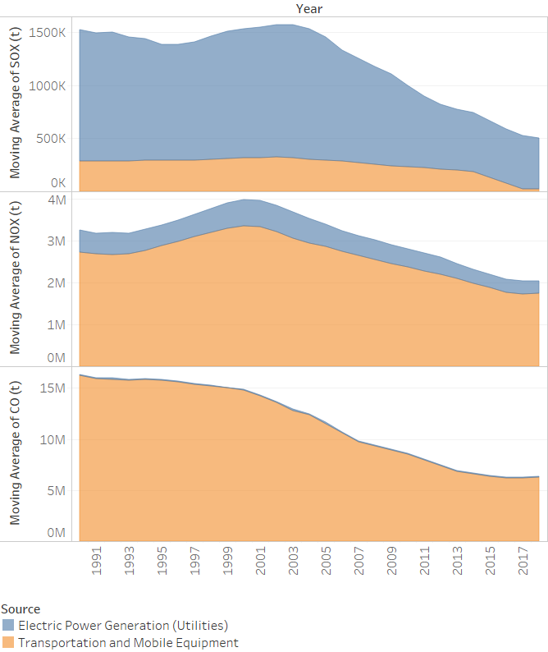

Figure 2 Emissions by sector

Figure 1 Average pollution per year by state

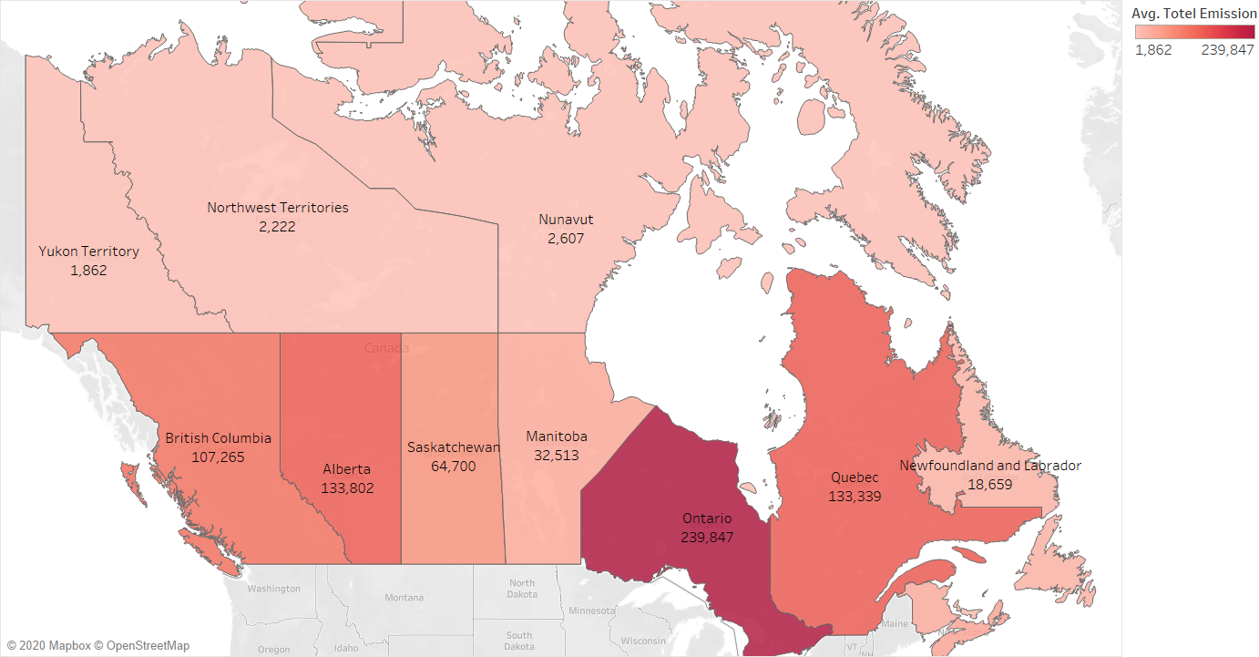

In the figure 2, we can see that electric power generation is the main source of the sulphur oxide gases in the atmosphere; covering about 80% of total emission and transportation have 20% share in Sox gases in the atmosphere. However, this 20% is reduced nearly to 0% in year 2016 due to adaptation of the electric vehicles in the transport industry. Still, transportation sector is emitting average 2.5 million tons of nitrogen oxide gases and 12 million tons of carbon oxide every year. The overall carbon oxide emission is reduced to nearly 50%, nitrogen oxide emission is reduced about 30%, and sulphur oxide emission is reduced by 70%.

Figure 3 shows the growth rate of CO(yellow), NOx(blue), and Sox(green) with respect to year 1991. In year 1992, 2.8% emission increment is observed and the 6% reduction in the next year is observed for sulphur oxide gases. The peak emission of CO and NOx are recorded in 1993 and 1996, respectively. By the end of the 2018, growth rate of CO is decreased by 3.17%, NOx is decreased by 1.45% and Sox is decreased by 3.95% as compared to year 1991.

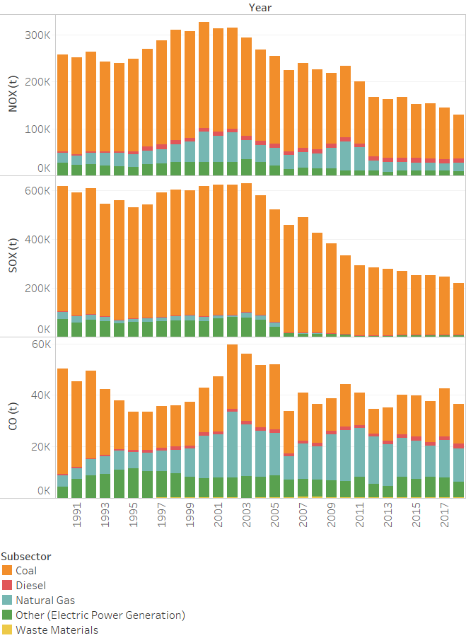

Figure 4 Pollution by electricity generation

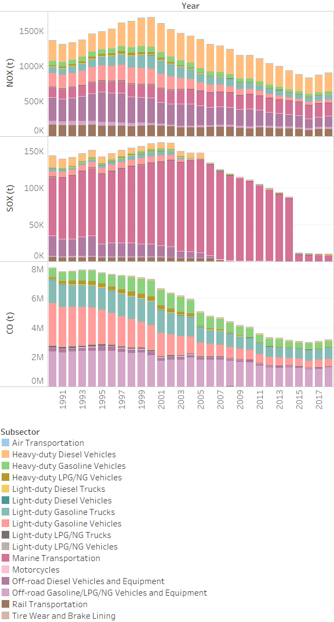

Figure 5 Pollution by Transportation

Figure 3 Growth rate of the gases

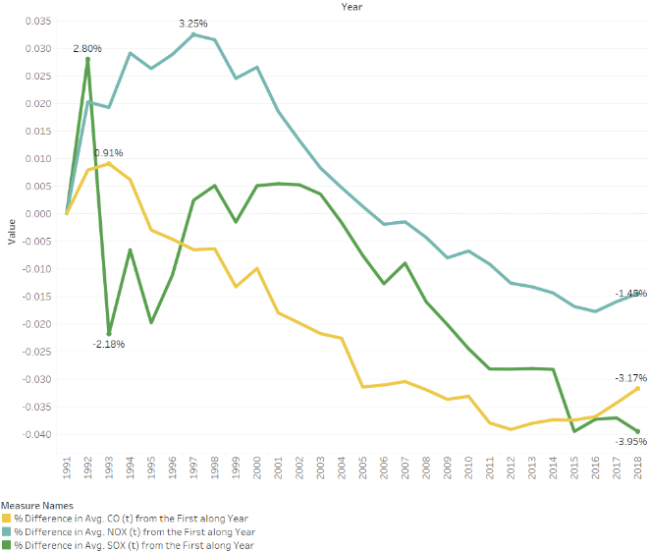

Now we will see the major pollutant of these gases by sector. In figure 4, we can see that CO (50%), NOx(80%), and SOx(90%) gases are emitted by burning coal. Hence, we can say that the major reason for emission of these gases in power generation is coal; followed by natural gas in carbon oxide emission. Figure 5 indicates the emission of these gases by various modes of transportation. We can see the huge reduction of SOx gases emission in year 2015 by marine transportation, which is the major pollutant of SOx from year 1990 to 2015. After 2015 we can see the total emission of SOx gases are dropped by about 90% of total. The CO and NOx emission have steady decrease from year 2001 to 2015 and have slight increase from year 2016 to 2018.

1. Generation

In this section, we will analyse the data about Electricity generated by various sources in Canada. Figure 6 shows the average electricity generation in the Canada by state per year. We can see from the map that Quebec is the leader in the electricity generation, generating around four million mega watt hour electricity in a year. Followed by Ontario (2.5 million MWh), Alberta (1.4 million MWh), and British Columbia (1.3 million MWh). The low population area Nunavut, Yukon and Northwest Territories generated very few 7290 MWh, 15039 MWh and 18620 MWh due to low demand. Next, we will see in the detail about the major sources of electricity in Canada.

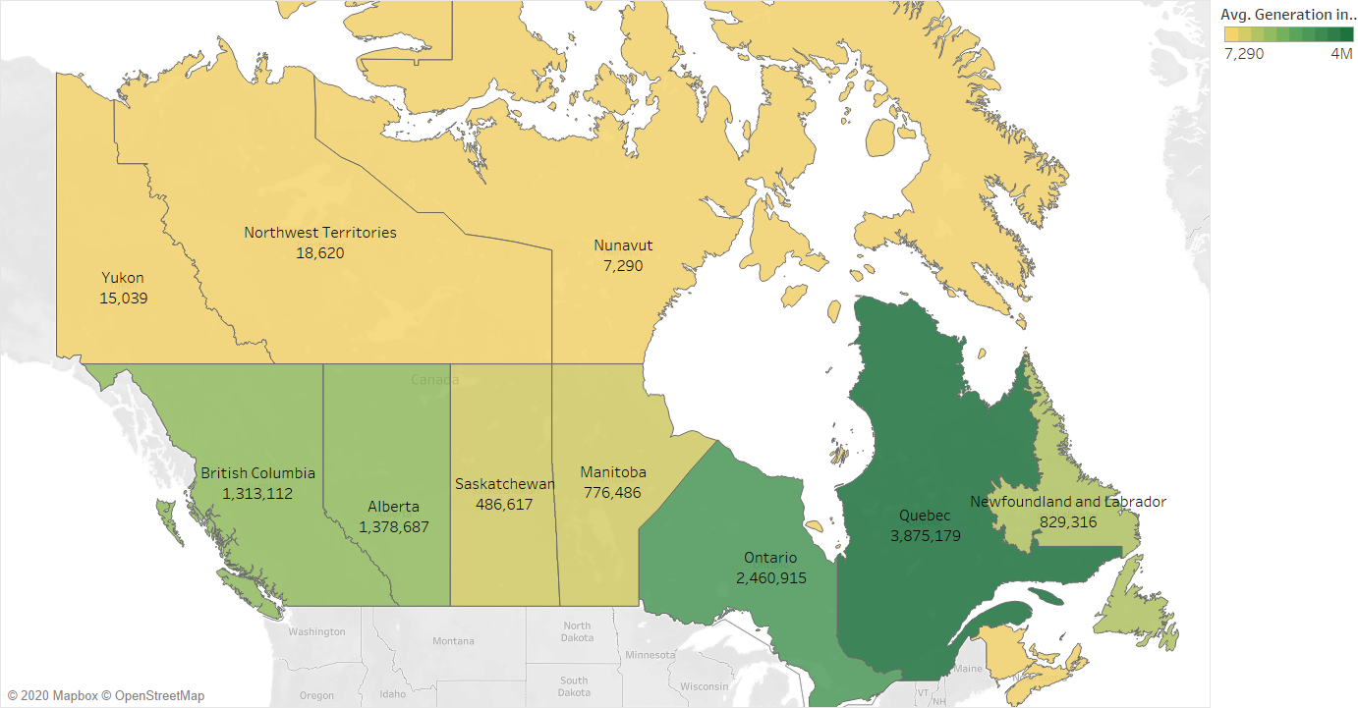

Figure 6 Average power generation by state

The figure 7 shows the average generation in MWh by various source in Canada. We can see the major three sources of the electricity generation in Canada are hydraulic turbine, nuclear steam turbine, conventional steam turbine, and combustion turbine generating on average 20 million, 7.7 million, 5.3 million, and 1.3 million MWh per year, respectively. However, conventional steam turbine and combustion turbine are the major sourced of air pollutants in the generation of electricity. We can notice that wind power turbine, solar and tidal power turbine have very less generating capacity in Canada. We will see the generation electricity by solar, wind and steam turbine from year 2008 to 2019 next.

Figure 7 Generation by type

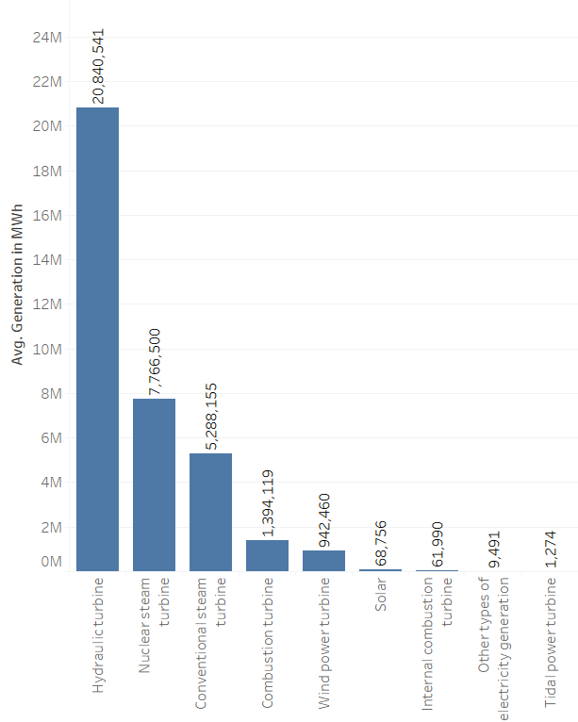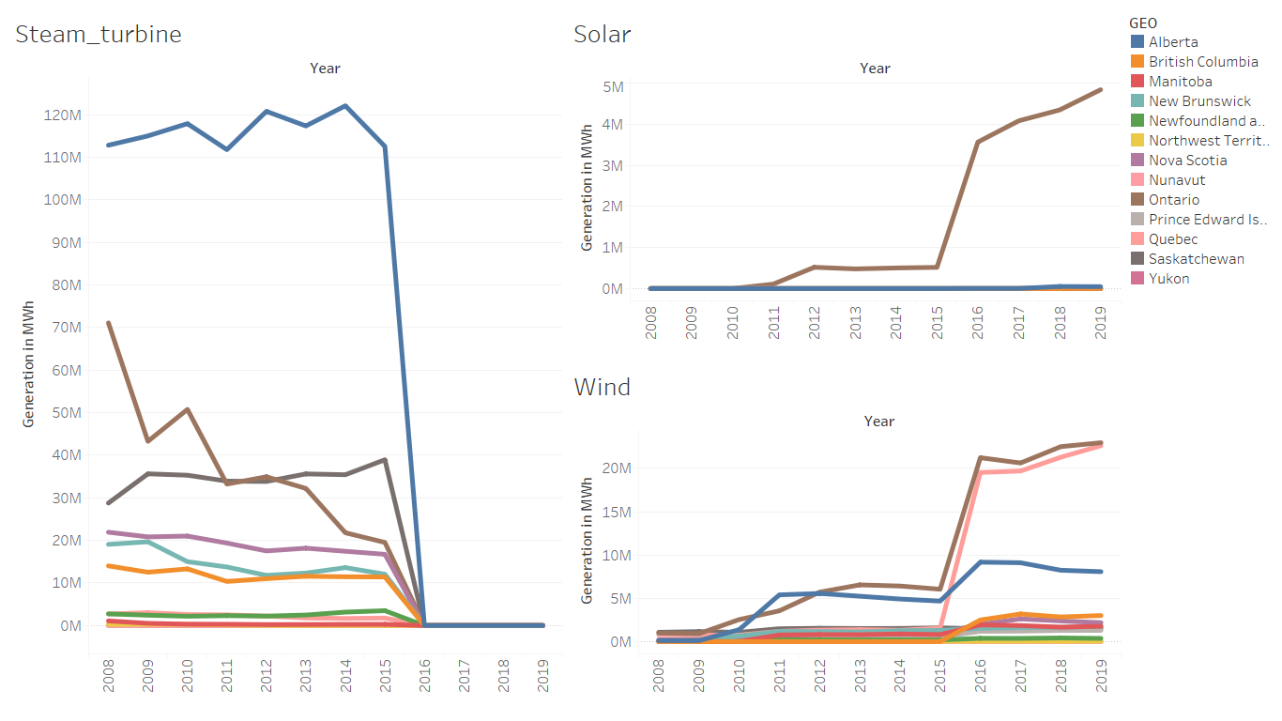

Figure 8 Power generation from solar, wind and steam turbine

In figure 8, we can see the major changes in the steam turbine, solar and wing power generation between year 2015 and 2016. In year 2008, Alberta, Ontario, and Saskatchewan are the leading states in power generation by steam turbines, generating 112 million, 70 million and 30 million MWh electricity. In which Alberta was generating electricity from steam turbines more than any other states of Canada. At the starting of year 2015, we can see the sudden drop in the steam turbine generation from every state of Canada drops to nearly zero in year 2016. It should be noted that within the same period of 2015 to 2016, Ontario have a sudden surge in electricity generation by solar and Ontario, Alberta and Quebec have sudden surge in wind power generation. So, we can say that government of Canada had close all the unconventional source of electricity and move towards more conventional sources like solar and wind to counter climate change.

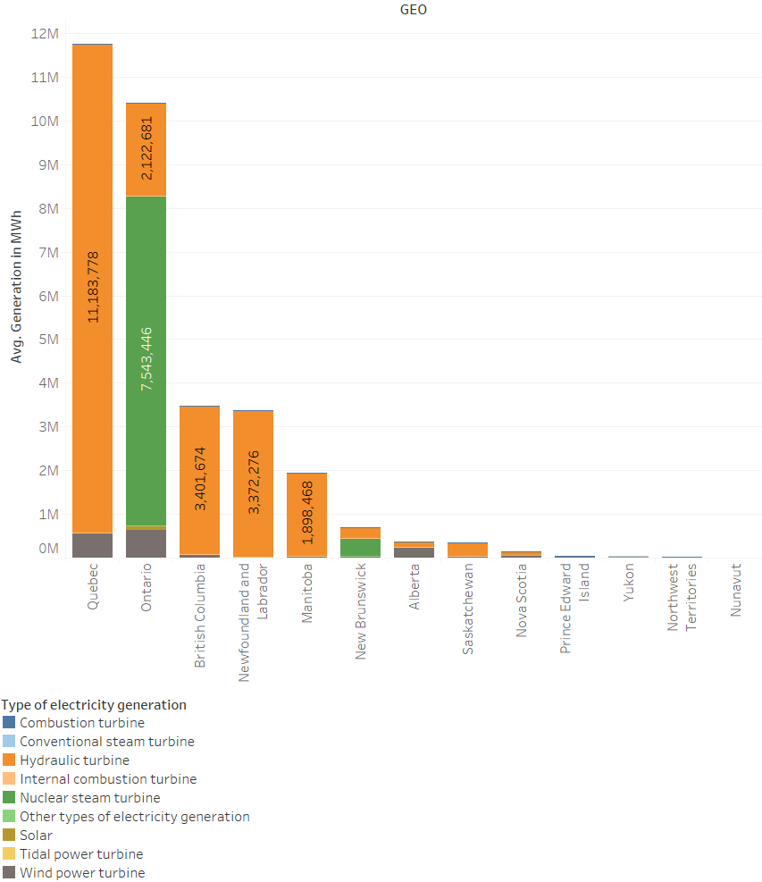

Figure 10 Generation by state after 2016

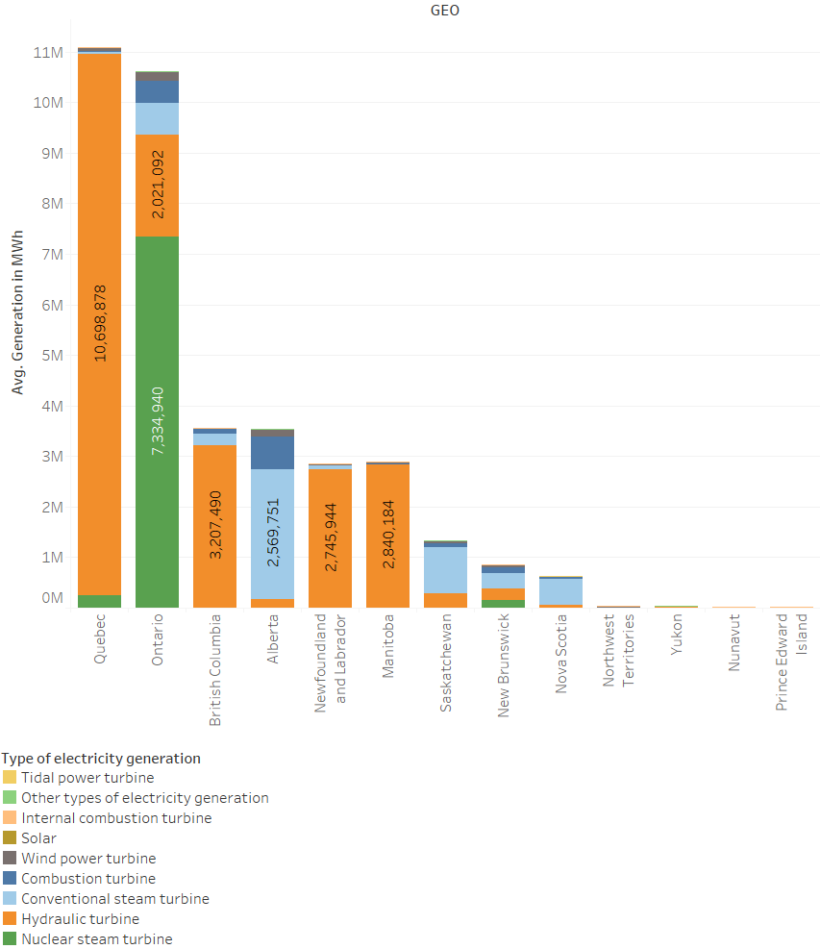

Figure 9 Generation by state before 2016

As we saw the major changes between year 2015 and 2016, we will compare the average electricity generation before 2016 and after 2016 in the states of Canada. The figures 9 and 10 shows the electricity generation by state and the different colours of each state indicates the different type of sources used to generate the electricity. In the figure 9 we can see the blue and light blue bars in Ontario, British Columbia, Alberta, Saskatchewan, New Brunswick, and Nova Scotia. Here dark blue indicates the generation using combustion turbine and light blue indicates the generation by conventional steam turbine. As we have seen in the figure 8, combustion turbine and conventional steam turbine are discontinued by the year of 2016 from all states of Canada. Hence, you can see that figure 10 does not have any blue sections in the bars. Before the 2016, we can see that Alberta ranked fourth on the average electricity generation by year in Canada. After 2016, Alberta dropped at seventh place from fourth and generating its major electricity by wind and hydraulic generators. As Quebec is the most electricity generating state of Canada, having 61 different hydro power plants generating around 11million MWh electricity per year, and generating on average around 0.5 million MWh electricity by solar power plants. Ontario on other hand, leading in solar, and nuclear power generation in Canada generating 0.6 million MWh and 7.5million MWh electricity per year. Ontario and New Brunswick are only two states generating electricity by nuclear power plants in Canada. From figure 10, we can see that British Columbia, Newfoundland and Labour, Manitoba and Saskatchewan generate around their 95% electricity using hydraulic turbines, generating 3.4million, 3.3million, 1.9million and 0.3million MWh electricity per year.

Figure 11 Total sales of electric vehicles from 2011 to 2018

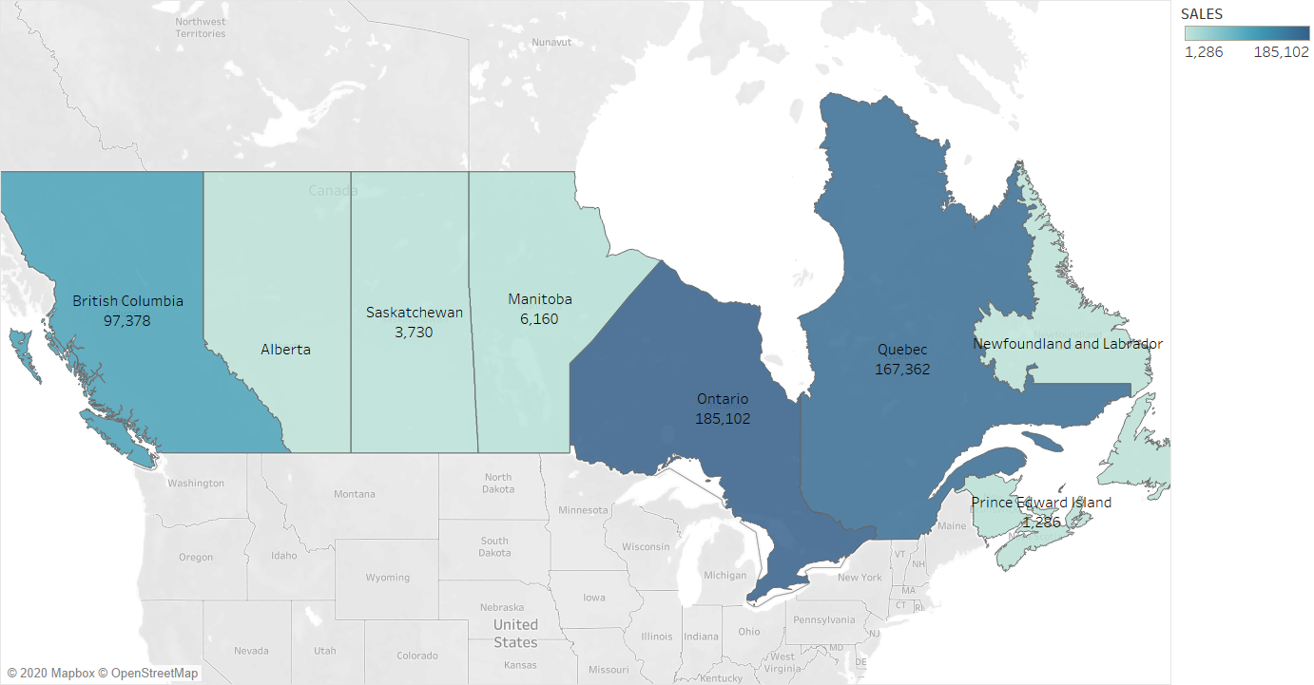

1. Electric Vehicle Sales

In this section, we are analysing the sales of battery electric vehicles(BEVs), hybrid electric vehicles(HEVs), and plug-in hybrid electric vehicles(PHEVs). Where BEVs are entirely powered by electric battery pack and driven by electric motor. For example, Tesla Model 3, BMW i3, and Chevy Bolt. Hybrid electric vehicle are driven by both electric motor and combustion engine. However, the battery of this vehicles cannot be charged by plugging to the electric outlet. The examples of HEVs are Ford Fusion Energi and Mini Cooper SE Countryman. The plug-in hybrid electric vehicle is same as the hybrid electric vehicles but have an advantage that the battery of the vehicle can be charged by plug in to the electric outlet.

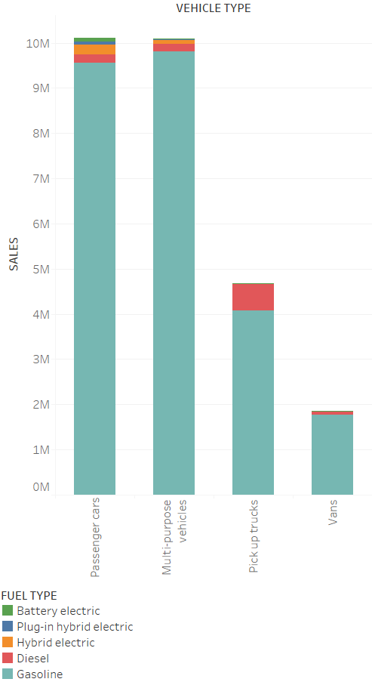

Figure 12 Sales of vehicles by fuel type

Figure 11 shows the total sales of BEVs, HEVs, and PHEVs in various sates of Canada. As the colour goes dark, more sales of electric vehicles in that region. From the figure we can see that Ontario is the leading state in the sales of EVs having the total sales of 185,102 sales of electric vehicles from 2011 to 2018. Ontario is followed by Quebec and British Columbia having 167,362 and 97,378 EVs sold by 2018.

Now we will discuss how electric vehicles sales changes form year 2011 to 2018. But first we will se the market of all vehicles by the type of the vehicle. Figure 12 shows the main four types of vehicles are sold in Canada which are Passenger cars, Multi-purpose vehicles, Pickup trucks and Vans. Figure clearly indicated that about 95% of the vehicle market in Canada is of gasoline fuel vehicle followed by diesel and hybrid electric vehicles. Now, we will focus on the combined sales of BEVs, HEVs, and PHEVs in Canada.

Figure 13 shows the different type of electric vehicles sold by year. It shows the trend is in exponential growth in sales from 2015 to 2018. With various and cheaper options available in the market, the sales of passenger cars are increased by 118.11% in just three years. Followed by Multi-purpose electric vehicles, sales are increased by 763.347%. The sales of pickup trucks and vans is not that much impressive due to very limited and expensive models available. Now we will see the sales of BEVs, HEVs, and PHEVs throughout the same period. In figure 14, we can see the exponential increase in the sales of BEVs and PHEVs with increase of 443.2% and 671.6% respectively in last three years. By using the data of figure 9, we can predict the future sales of the electric vehicles by its fuel types as shown below.

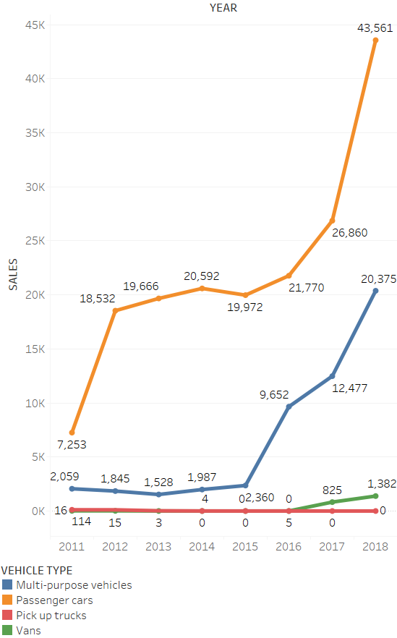

Figure 13 EVs sales by vehicle type

Figure 13 EVs sales by vehicle type

Figure 14 EVs sales by fuel type

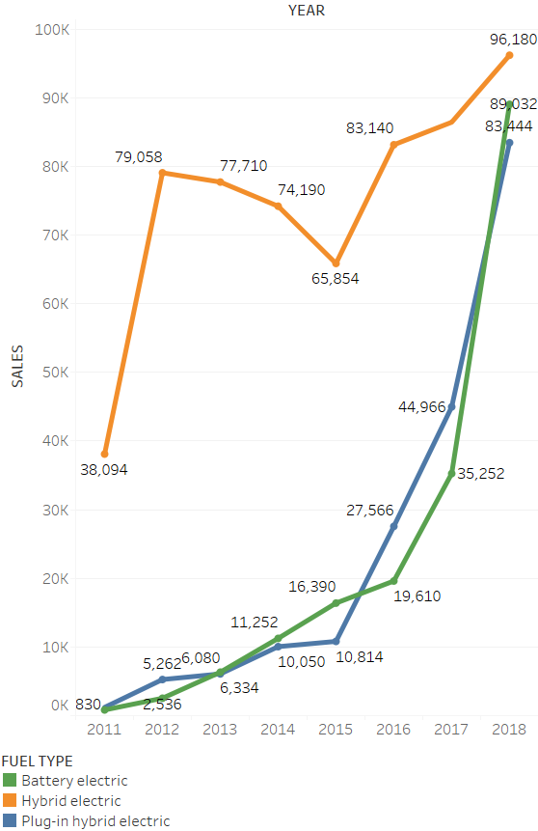

Figure shows the expected sales of battery electric vehicles, hybrid electric vehicles and plug-in hybrid electric vehicles. We can see the exponential growth in sales of these three type electric vehicles. The expected growth of hybrid electric vehicle in 2025 from 2011 is 2634.63% with the sales of 1,041,730 sales. The growth of plug-in hybrid electric vehicle is 83128.9% is expected with 1,005,405 sales; and for battery electric vehicles the growth is expected at 160949% increase with 1,336,708 sales. With increasing demand of passenger cars like Tesla model 3, the sales of battery electric vehicles are predicted to leave behind the sales of HEVs and PHEVs by 2025. The total electric vehicles sales is shown in figure 16 showing around 3 million electric vehicle sales by year 2025 in Canada.

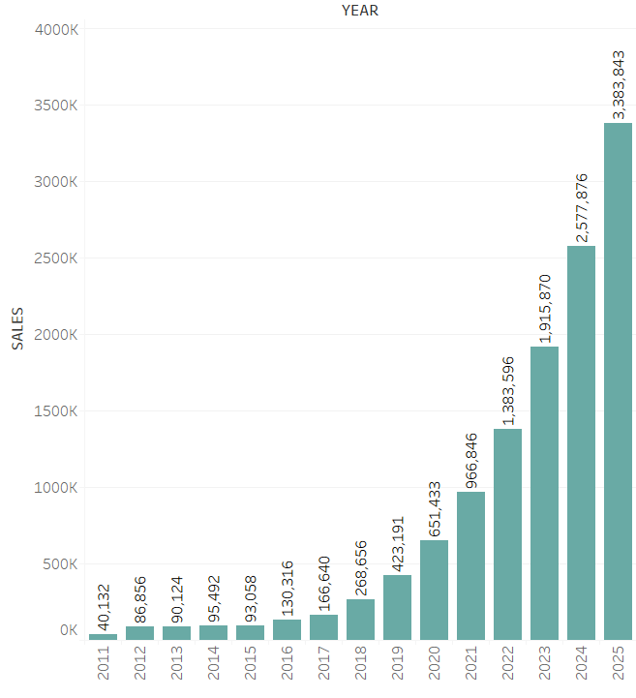

Figure 16 Total EV sales by 2025

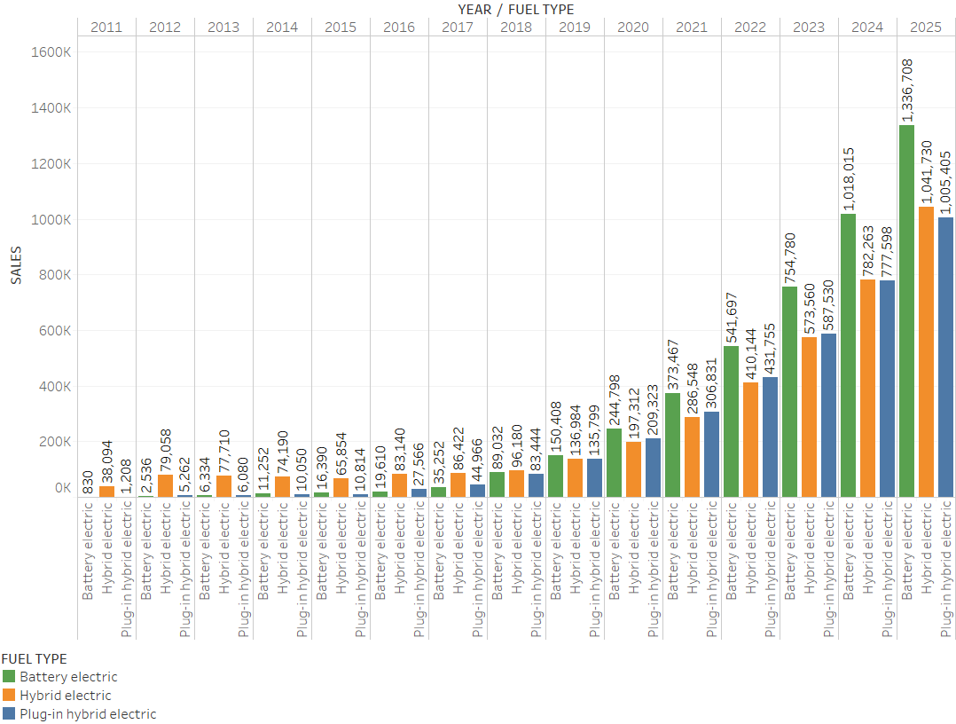

Figure 15 Prediction of EV sales by fuel type

Conclusion:

In conclusion, we can say that air pollution in Canada is decreasing on the yearly basis with the development of the industries and technology. The steady decrease in the CO, SOx and NOx gases can be seen and it will be decreasing as the time goes. The major emission of the gases is coming from the transportation industries and it is important to find the ways to reduce the emissions from the transportations.

After that we saw the closing of the steam turbine and increasing the use of wind and solar plants, we can say that Canada will generate electricity from all the conventional sources helping the environment.

At last, as all the care manufacturing companies are moving towards the electrification of their cars and the innovation and technology helps them to manufacture vehicles at low cost, the demand of the electric vehicles will increase and sales as well.

Reference:

1. Data Source: Statistics Canada (https://www.statcan.gc.ca/eng/start)